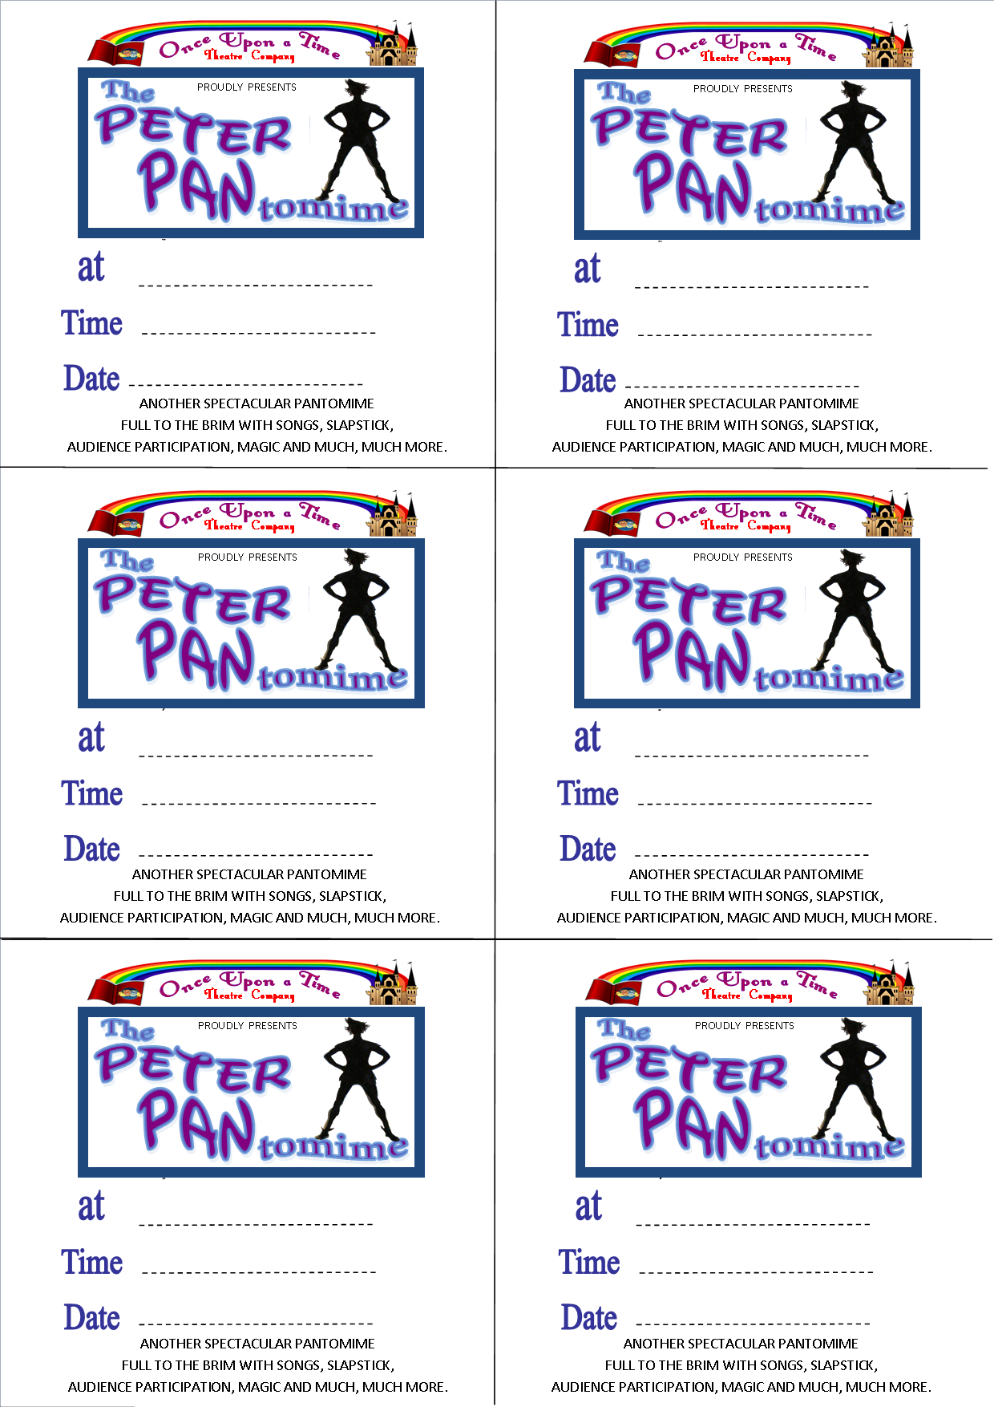

Date

Time

Venue Name

Date

Time

Venue Name

Date

Time

Venue Name

Date

Time

Venue Name

Date

Time

Venue Name

Date

Venue Name

Time